**we will use state with class component. We will convert the function into class in “App.js” file ↓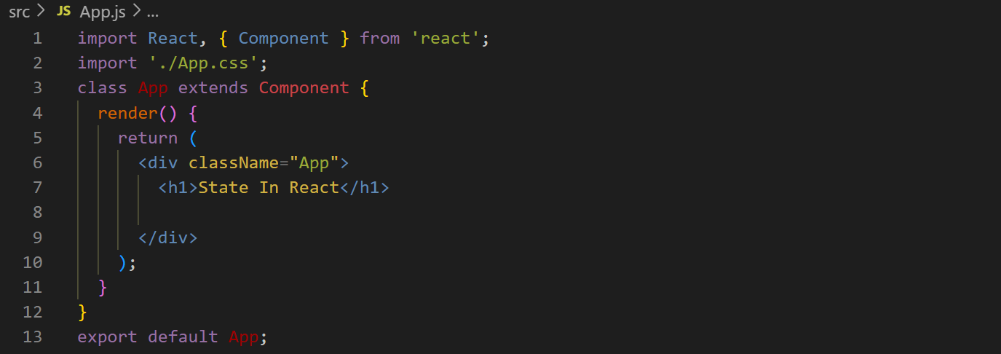Now we will create a constructor ↓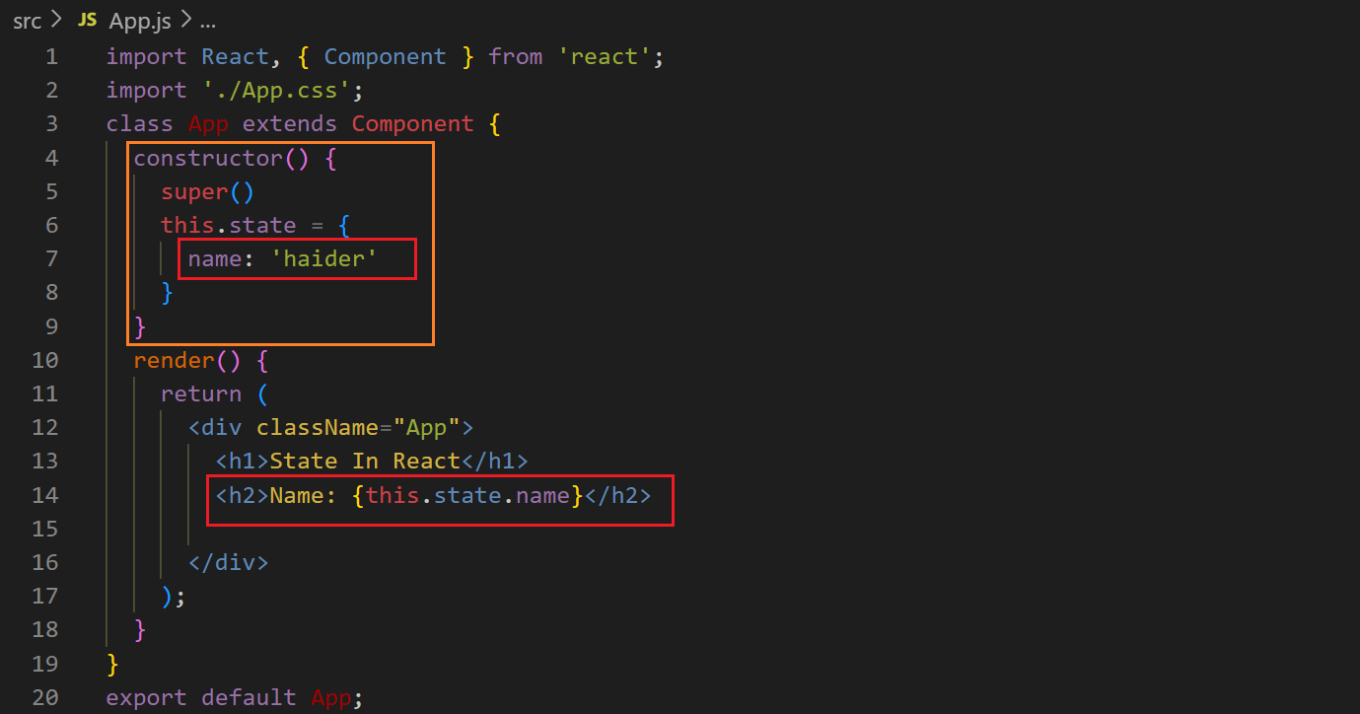Output ↓**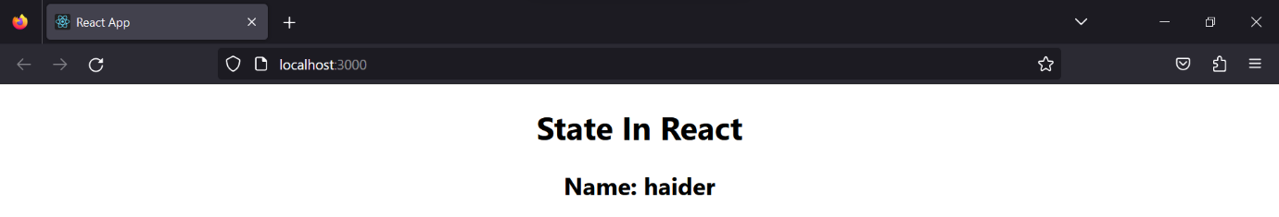

**Now we will create a button create a function without “function” keyword and we have to use arrow function to call the function in the button ↓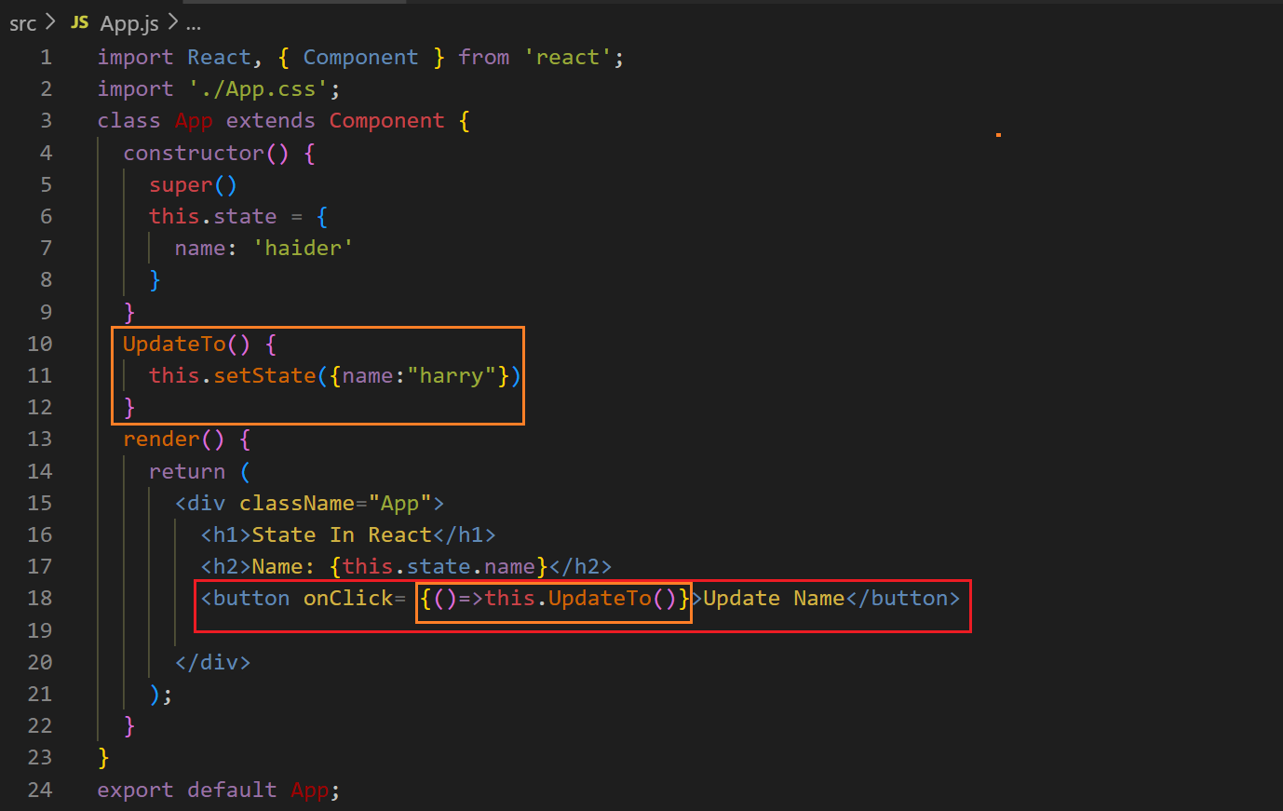After clicking the button ↓**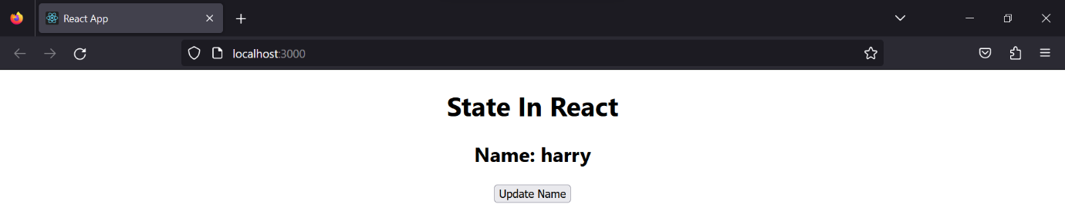

**We can use it with another purposes ↓**